AWS S3 – STATIC WEBSITE HOSTING
Page 1: Website Result – Suxam Nazar
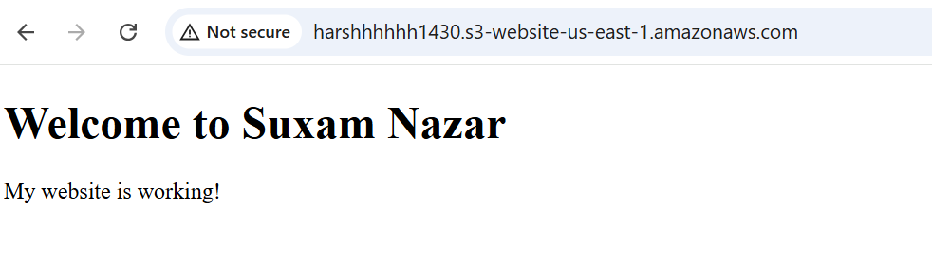
Explanation: The S3 static website is working and the browser displays the Suxam Nazar homepage. This confirms that the uploaded HTML page can be accessed through the S3 website endpoint.

AWS S3 – STATIC WEBSITE HOSTING
Page 2: Static Website Hosting Enabled
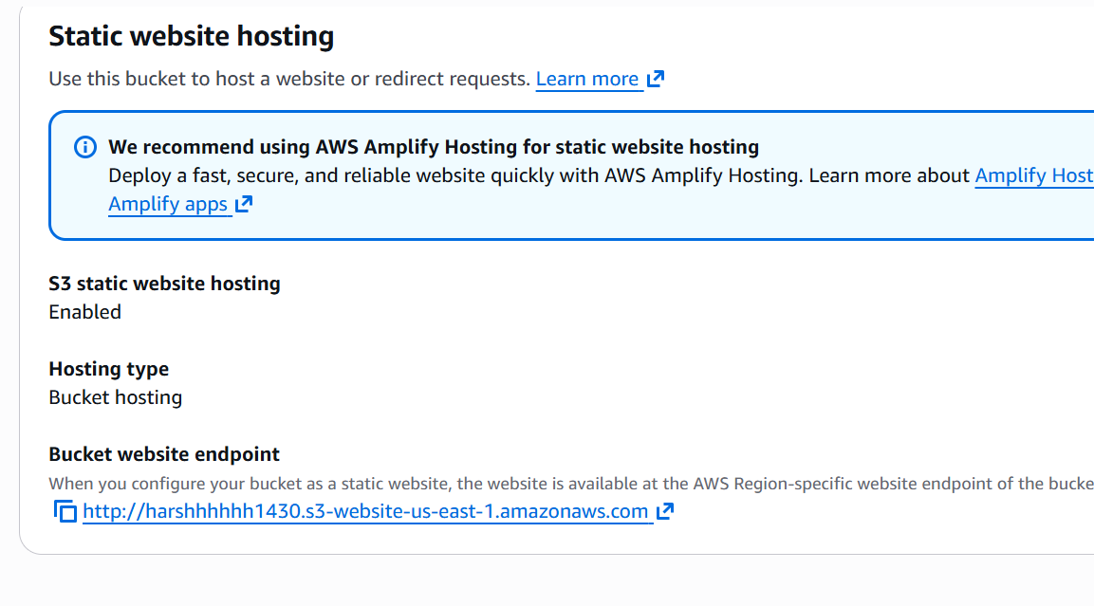
Explanation: Static website hosting is enabled for the bucket, and AWS shows the bucket website endpoint. This endpoint is used to open the hosted website.

AWS S3 – STATIC WEBSITE HOSTING
Page 3: Bucket Versioning Enabled
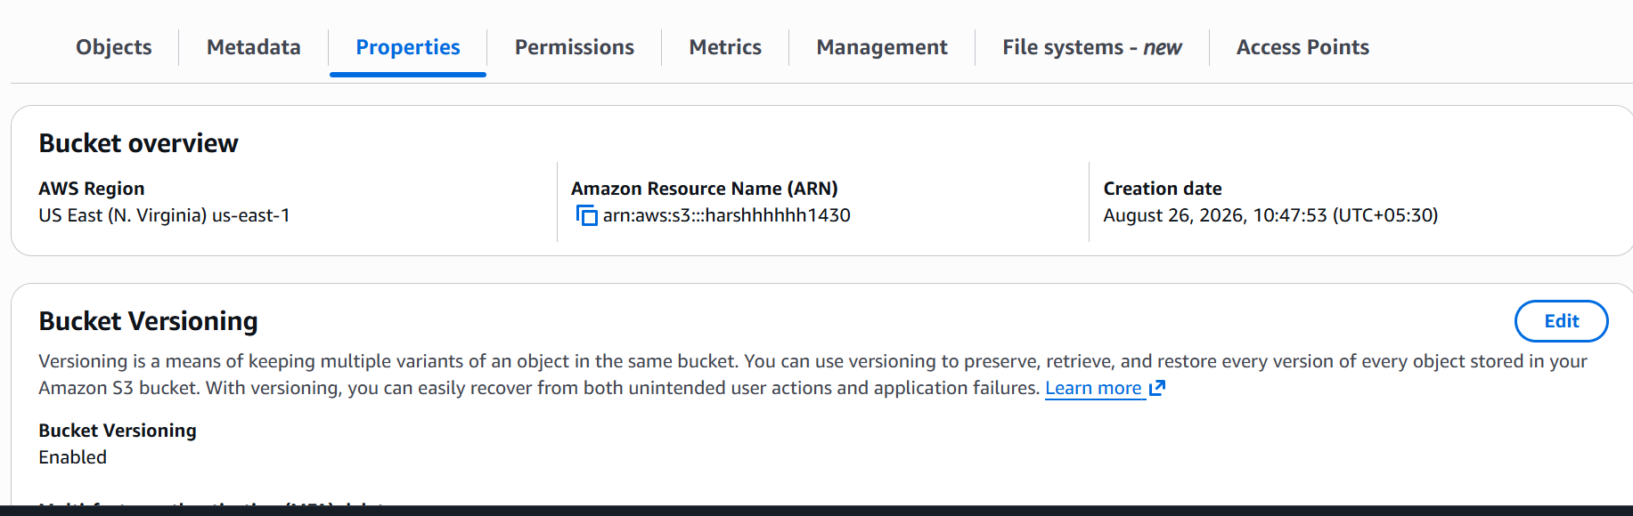
Explanation: Bucket Versioning is enabled. It keeps multiple versions of objects so that an older version can be recovered after an accidental change or deletion.

AWS S3 – STATIC WEBSITE HOSTING
Page 4: Bucket Policy JSON – Initial Policy View
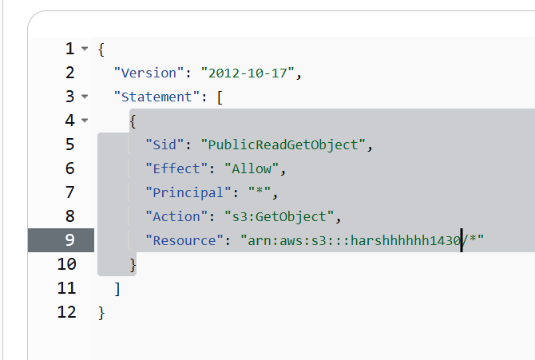
Explanation: This page shows the JSON structure used for an S3 bucket policy. The policy controls access to objects stored in the bucket.

AWS S3 – STATIC WEBSITE HOSTING
Page 5: Bucket Policy JSON – Public Read Policy
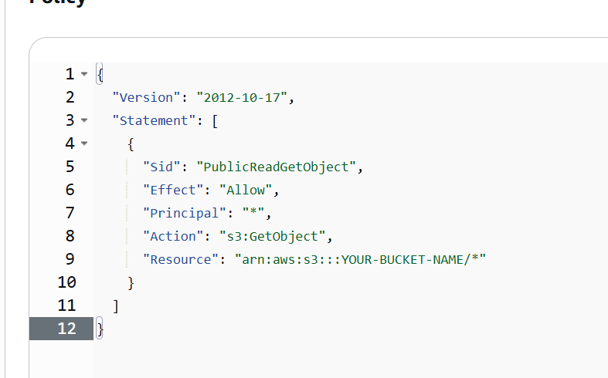
Explanation: The public-read policy is configured to allow the `s3:GetObject` action for objects in the bucket. The bucket name must be used in place of the placeholder in the Resource ARN.

AWS S3 – STATIC WEBSITE HOSTING
Page 6: Bucket Policy Page
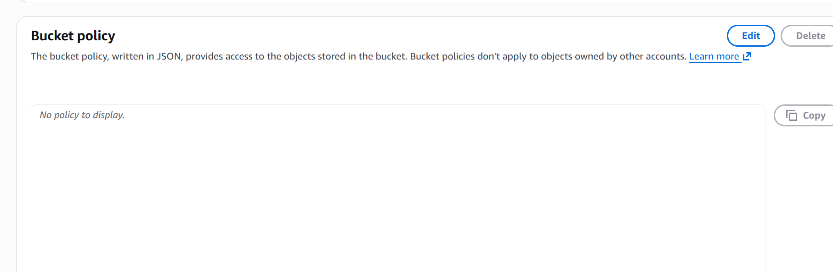
Explanation: The Bucket Policy section is opened to manage access to the objects in the bucket. A policy can be added here when public or specific access is required.

AWS S3 – STATIC WEBSITE HOSTING
Page 7: Bucket Permissions Overview
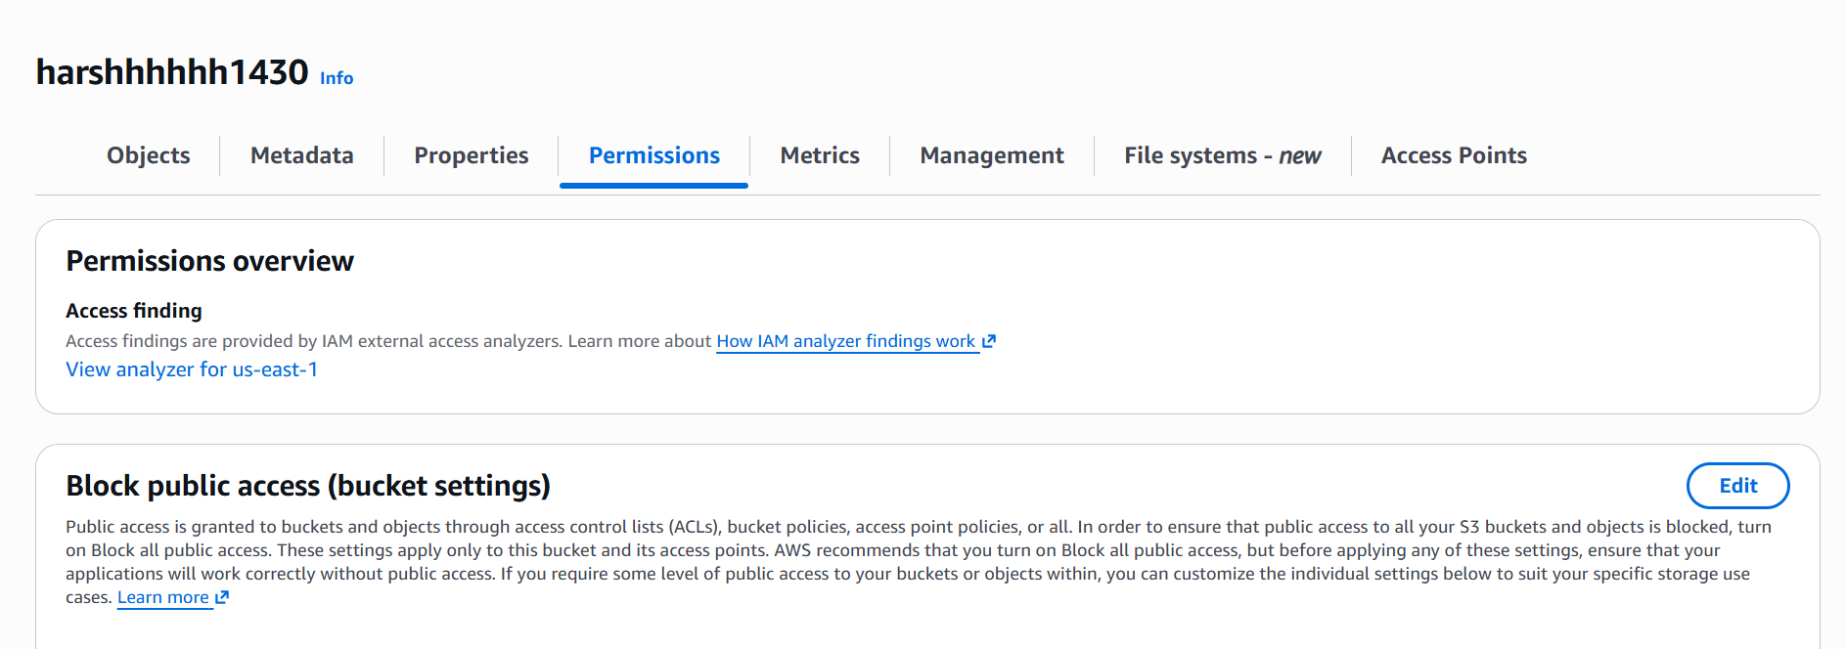
Explanation: The Permissions page shows the bucket's public-access settings. These settings are important when making a static website publicly reachable.

AWS S3 – STATIC WEBSITE HOSTING
Page 8: Index Document Configuration
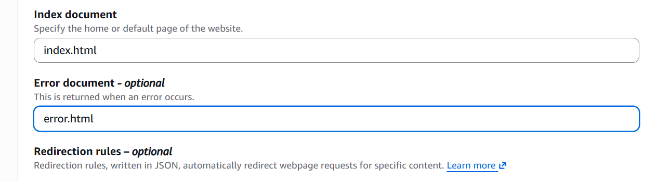
Explanation: The website's default document is set to `index.html`. This tells S3 which page to return when the website endpoint is opened.

AWS S3 – STATIC WEBSITE HOSTING
Page 9: Edit Static Website Hosting
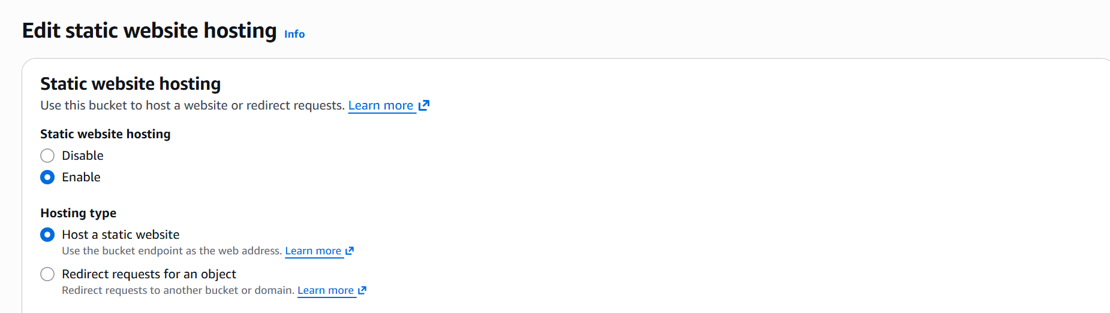
Explanation: The Static Website Hosting edit screen is used to enable website hosting and select the hosting type. The bucket endpoint becomes the web address for the site.

AWS S3 – STATIC WEBSITE HOSTING
Page 10: Static Website Hosting – Disabled State
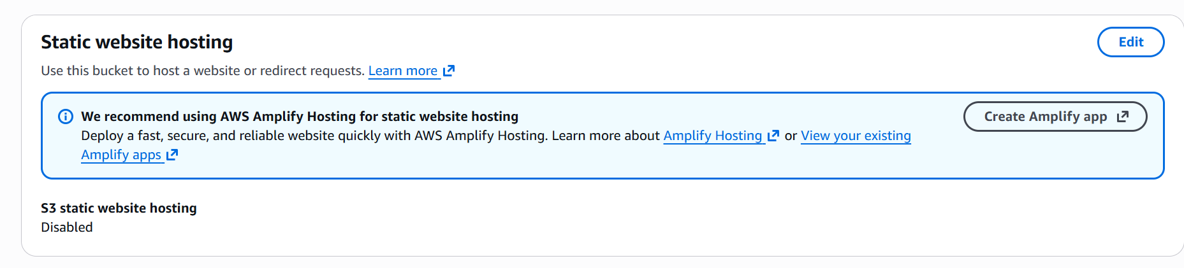
Explanation: This screenshot shows the static website hosting setting in the disabled state before it was enabled. It is the starting configuration for website hosting.

AWS S3 – STATIC WEBSITE HOSTING
Page 11: Bucket Overview and Versioning
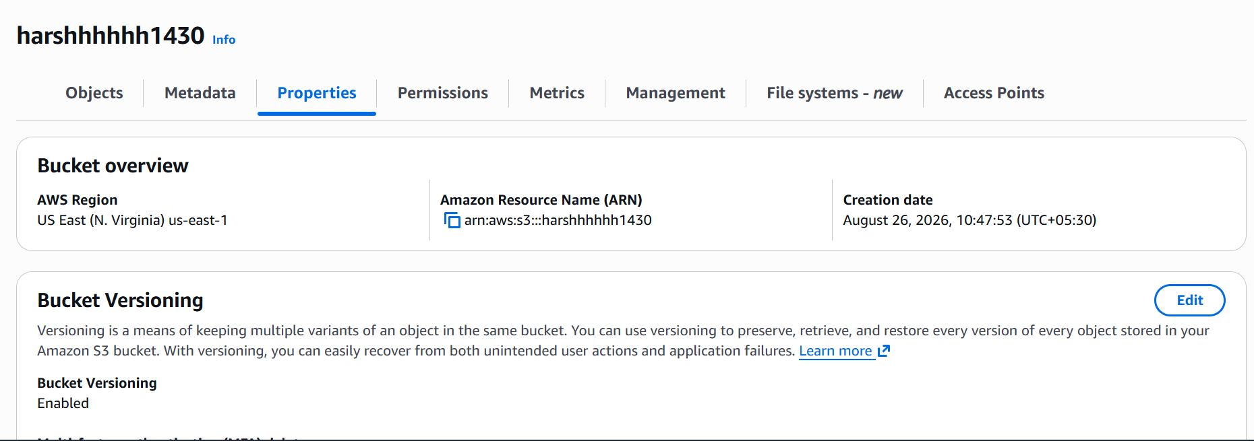
Explanation: The bucket overview shows the AWS Region, ARN, and Versioning status. These are the main configuration details of the S3 bucket.

AWS S3 – STATIC WEBSITE HOSTING
Page 12: Destination Information
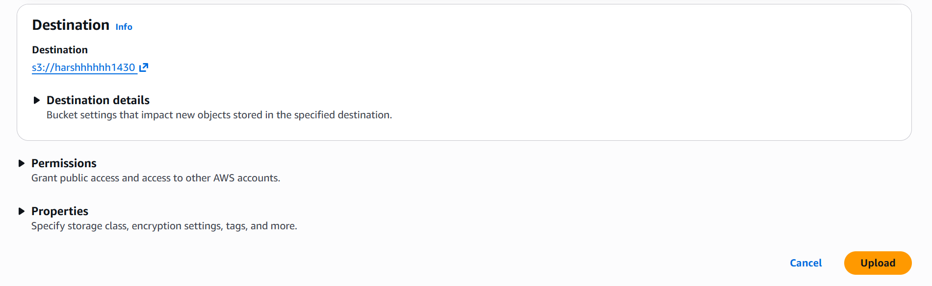
Explanation: This page shows destination information for an S3 destination bucket. It contains the destination bucket and settings related to permissions and properties.

AWS S3 – STATIC WEBSITE HOSTING
Page 13: Upload – index.html Selected
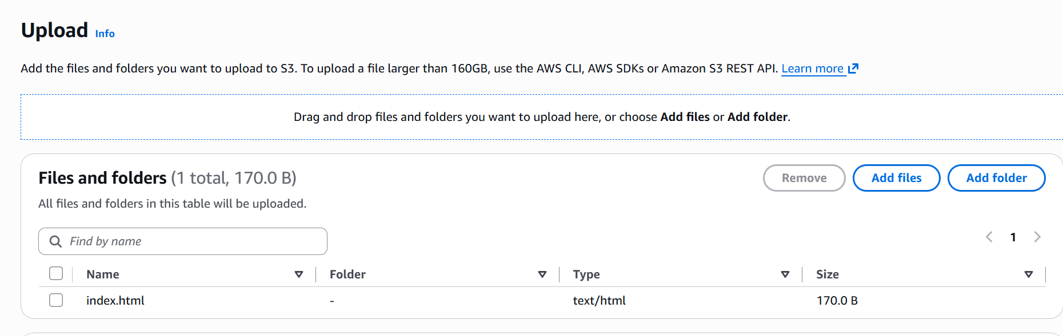
Explanation: The S3 Upload page shows `index.html` selected for upload, with its content type recognized as `text/html`. This is the correct file type for the website home page.

AWS S3 – STATIC WEBSITE HOSTING
Page 14: Upload Page – No File Selected
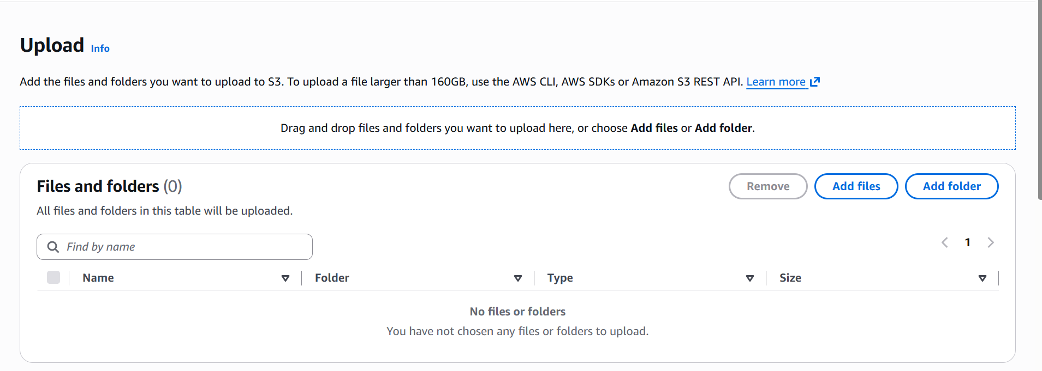
Explanation: The Upload page is open but no file has been selected yet. The Add files button is used to choose the website files from the computer.

AWS S3 – STATIC WEBSITE HOSTING
Page 15: Local File Type – index.html

Explanation: The local file is shown as `index` and recognized by Windows as a Microsoft Edge HTML Document. This confirms that the file has been created as an HTML document.

AWS S3 – STATIC WEBSITE HOSTING
Page 16: S3 Objects Page
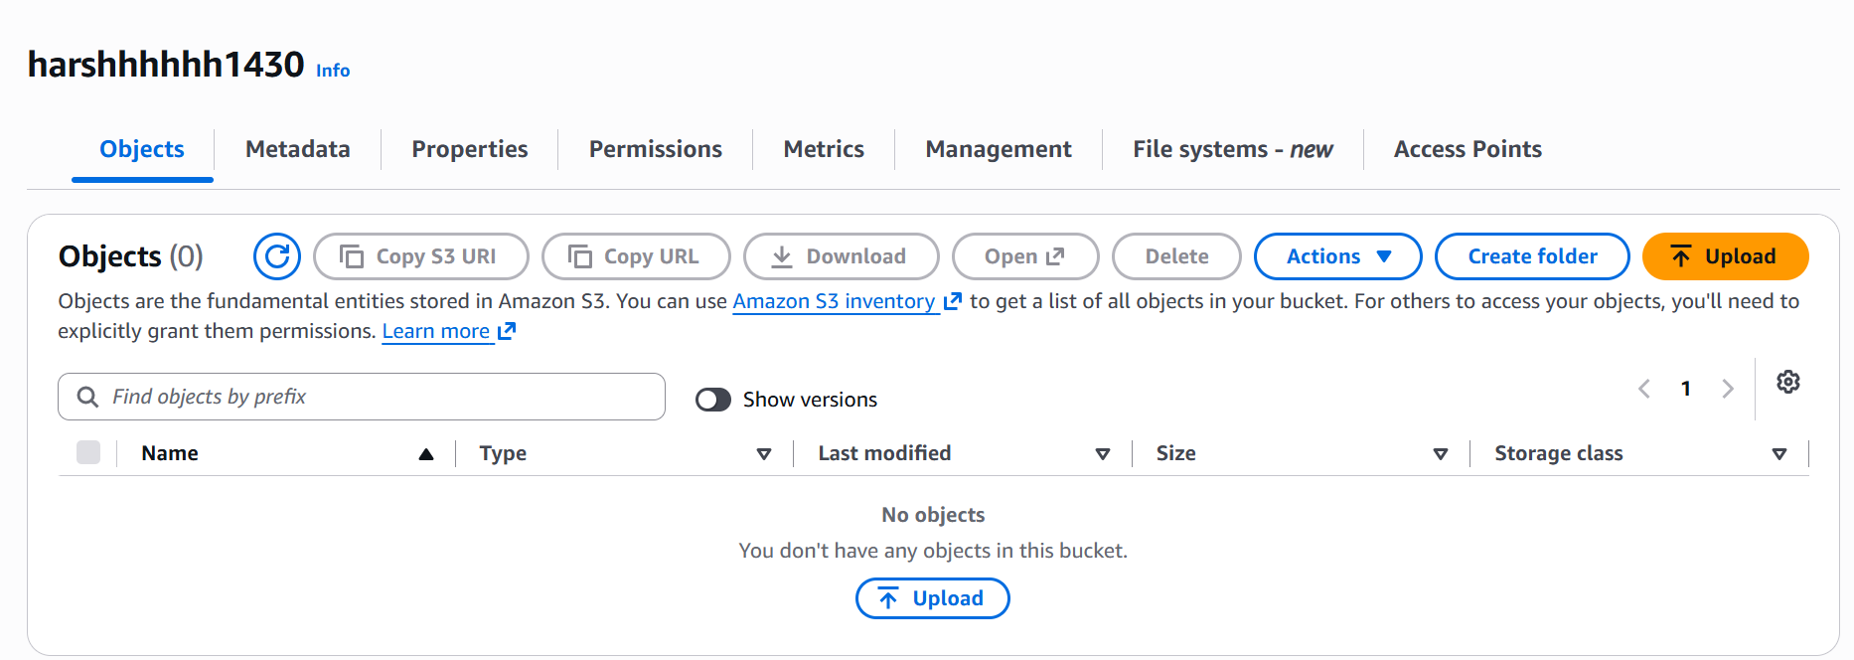
Explanation: The S3 Objects page is used to view files stored in the bucket. At this stage the bucket shown in the screenshot has no objects yet.

AWS S3 – STATIC WEBSITE HOSTING
Page 17: Advanced Bucket Settings
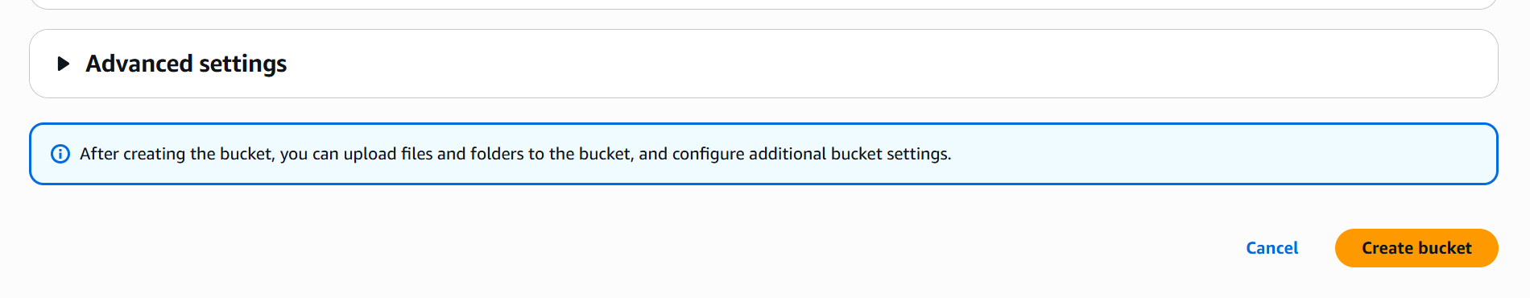
Explanation: The Advanced Settings section is part of the bucket-creation process. It provides additional options that can be configured after creating the bucket.

AWS S3 – STATIC WEBSITE HOSTING
Page 18: Bucket Versioning – Create Bucket
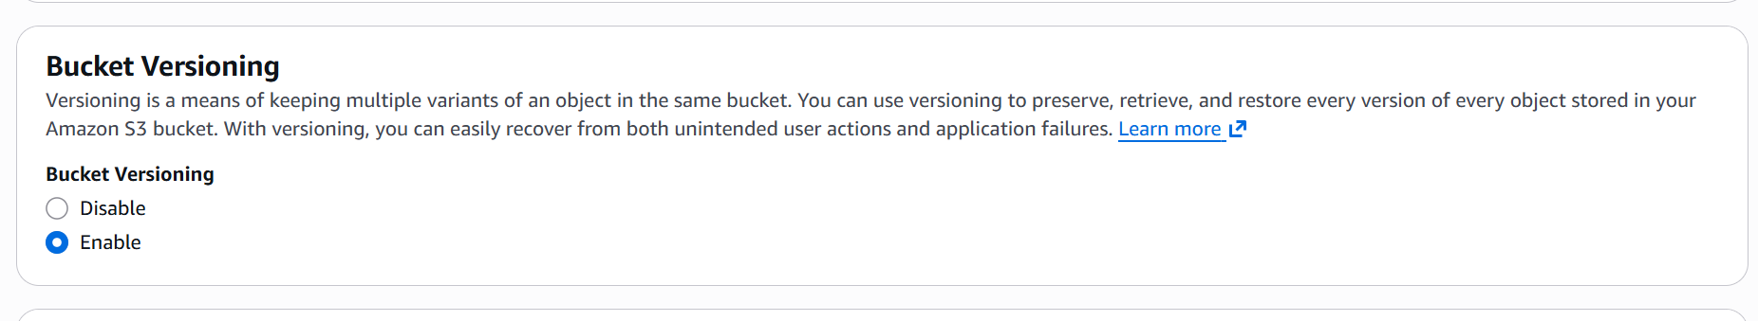
Explanation: Bucket Versioning can be enabled while creating or configuring the bucket. Enabling it helps preserve previous versions of uploaded objects.

AWS S3 – STATIC WEBSITE HOSTING
Page 19: Block Public Access Settings
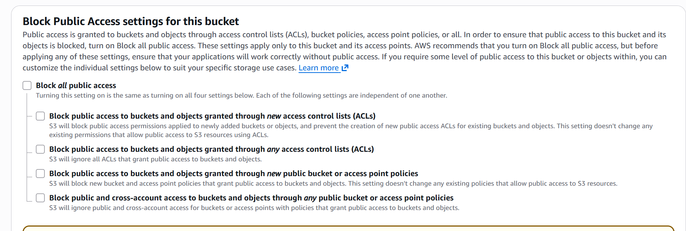
Explanation: These settings control whether public access to the bucket and its objects is blocked. For a public static website, the required public-access settings must be configured carefully.

AWS S3 – STATIC WEBSITE HOSTING
Page 20: Bucket Creation – Bucket Type and Namespace
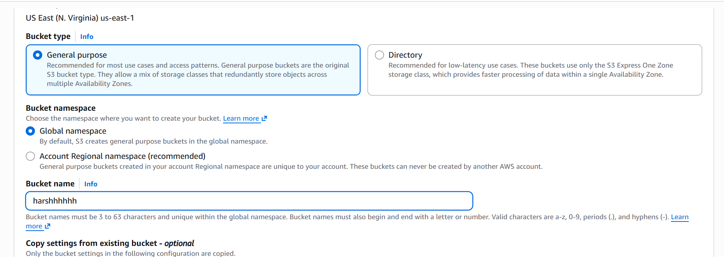
Explanation: This screen is part of bucket creation and shows the general-purpose bucket type and namespace options. A general-purpose bucket is the normal choice for a static website.

AWS S3 – STATIC WEBSITE HOSTING
Page 21: S3 Buckets Page
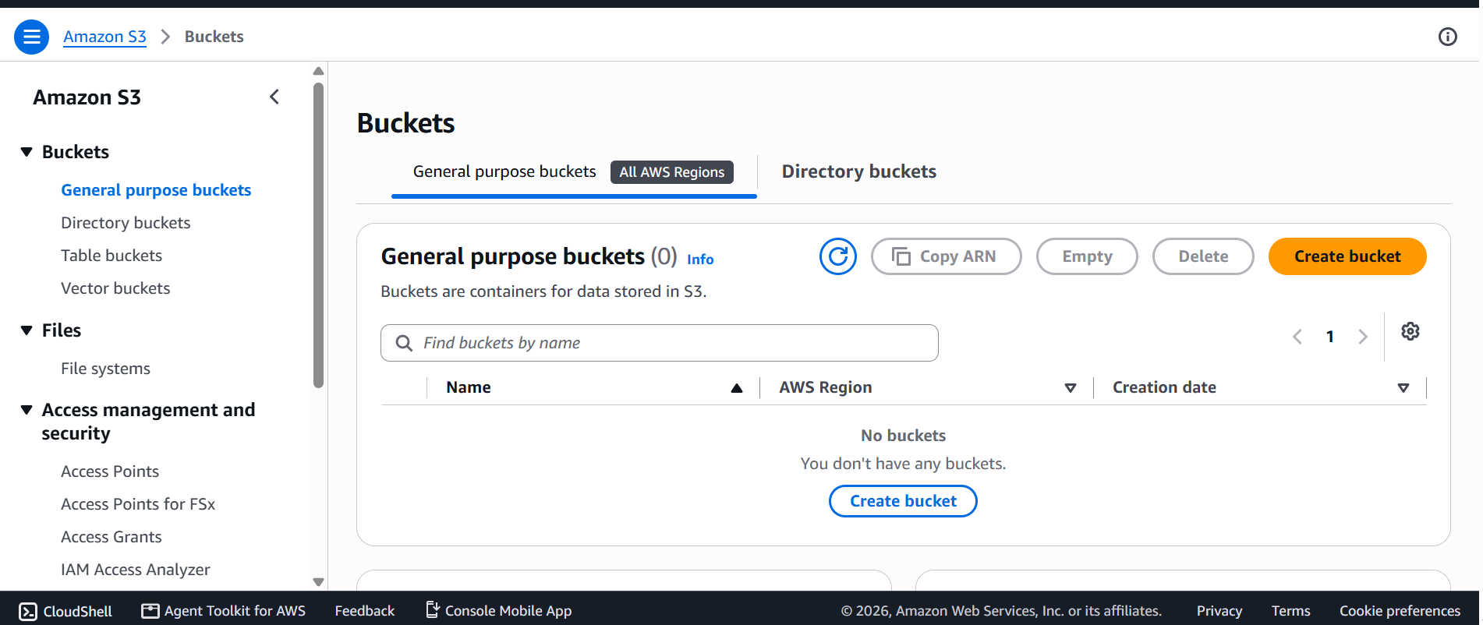
Explanation: The S3 Buckets page lists the buckets in the account. The screenshot shows that there were no buckets at that point, before the website bucket was created.

AWS S3 – STATIC WEBSITE HOSTING
Page 22: AWS Services – S3
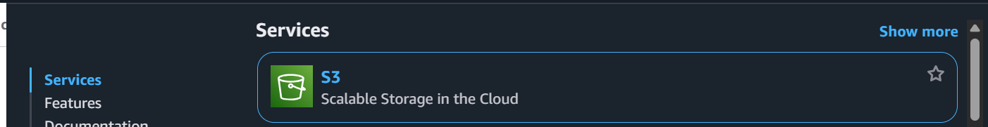
Explanation: This screenshot shows the AWS Services area where Amazon S3 is selected. S3 is the AWS service used for storing objects and hosting the static website.

